FILE PERMISSION:
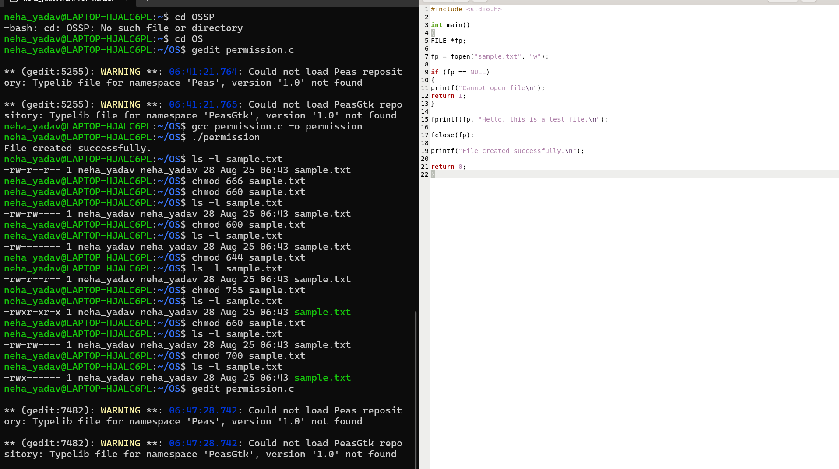
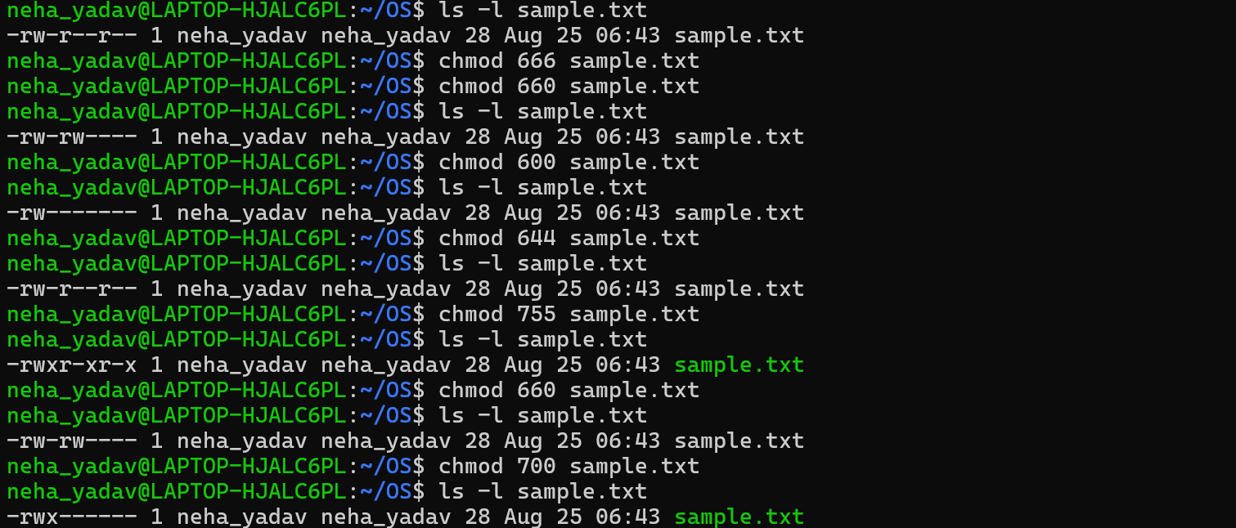
1. Owner: read + write; Group: nothing; Others: nothing →600
2. Owner: read + write; Group: read; Others: read → 644
3. Owner: read + write + execute; Group: read + execute; Others: read + execute → 755
4. Owner: read + write; Group: read + write; Others: nothing → 600
5. Everyone: read only → 444

